VoICE Press Release dated 13.07.2026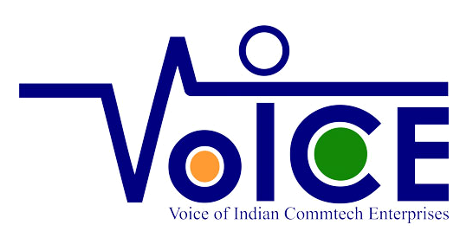
VoICE announces Strategic Tie-up with IIT Gandhinagar on 9th July 2026 as a follow up on MoUs with TSDSI, C-DOT to Scale India’s First Live AI-Smart Village

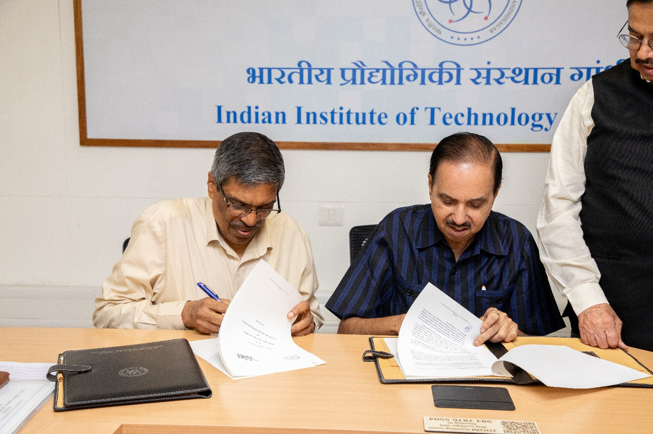
VoICE (Voice of Indian Communication Technology Enterprises), the premier apex body representing homegrown Indian telecom startups and MSMEs, has announced a major expansion of its indigenous deep-tech ecosystem. Led by Director General RK Bhatnagar, the consortium has officially signed a Memorandum of Understanding (MoU) with the Indian Institute of Science and Technology, Gandhinagar (IIT Gandhinagar) and solidified a technical partnership with the Centre for Development of Telecommunications (C-DOT) to scale India’s digital rural footprint.
The announcement follows the massive domestic success of the Satnavari Smart Village pilot in Nagpur, Maharashtra. Built at zero CAPEX risk to the state entirely by Indian MSMEs, Satnavari has evolved into a global reference model recognized by the International Telecommunication Union (ITU). The freshly inked MoU with IIT Gandhinagar will bring rigorous academic validation, advanced data-analytics governance, and scalable framework designs to rural AI applications. Concurrently, C-DOT is providing specialized support for a unified, high-security Smart Dashboard that serves as the central command-and-control layer for the village infrastructure.
In an unprecedented move toward absolute transparency in public infrastructure, the consortium has made the live deployment data verifiable by anyone. The "Smart Intelligent Village" application is now actively available on the Google Play Store for Android phones. Users can download the app to monitor real-time, live telemetry streaming directly from Satnavari’s field deployments, including precision agriculture soil sensors, aquaculture tracking metrics, edge-computed Wi-Fi loops, and smart street lighting.
"We have already proven our capabilities by successfully delivering end-to-end 5G and 5G Private Enterprise solutions across complex industrial landscapes," said RK Bhatnagar, DG, VoICE.
"With the Satnavari model, we have created the exact out-of-the-box 'Service Layer' that BharatNet Phase-3 requires to instantly monetize middle-mile fiber assets and spark immediate local digital demand."
Building on this momentum, the VoICE consortium revealed its next high-impact frontier initiative with an attempt on 100% Indian-made Drones. Moving away from foreign-dependent component chains, the alliance of domestic startups is actively engineering a completely indigenous drone platform. Every single layer of the stack—including communication links, hardware controllers, edge software, encryption security, and AI-driven surveillance—is being targeted integrated domestic design.
The consortium is currently approaching the Government of Maharashtra for the formal administrative approvals required to roll out this validated tech stack across an initial tranche of 75 smart villages, while simultaneously engaging the Ministry of Communications for Telecom Technology Development Fund (TTDF) deployment grants to scale the model nationwide.

