***Ready for Inauguration by* Hon’ble Chief Minister, Maharashtra Shri Devendra G. Fadnavis**

***Country’s FIRST SMART INTELLIGENT VILLAGE at SATNAVARI, Nagpur Rural***

***On 15th August/ 16 August 2025***

Maharashtra stands at the threshold of a digital revolution that can transform its 43,000+ villages into thriving smart communities. Wi-Fi and other technology options, once deployed strategically across rural areas, can serve as the foundational infrastructure to bridge the digital divide and unlock unprecedented opportunities for economic growth, social development, and improved quality of life for our rural population. Wi-Fi, Mobile and satellite technology offers unique advantages for rural deployment compared to traditional connectivity solutions. It provides cost-effective, scalable coverage that can reach remote areas with minimal infrastructure investment. Wi-Fi networks can be deployed using existing structures and powered by renewable energy sources, making them ideal for Maharashtra's diverse geographical landscape.

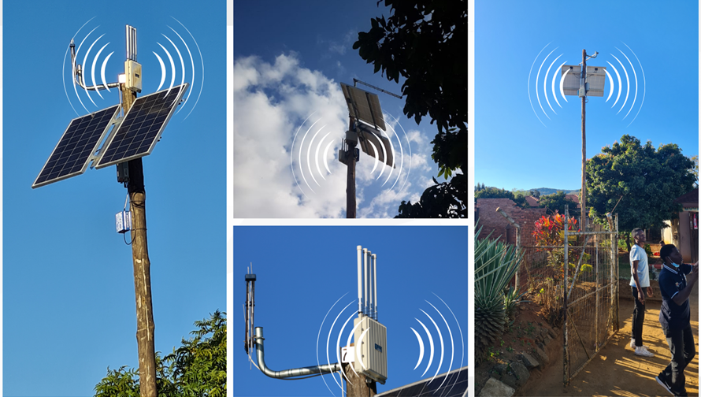

Wi-Fi technology will enable some of the following use-cases for Smart Intelligent Villages to start with:

* **Water Management Revolution**

Wi-Fi-enabled IoT sensors can monitor groundwater levels, soil moisture, and rainfall patterns in real-time. Farmers can receive alerts on their smartphones about optimal irrigation timing, preventing water wastage and improving crop yields.

* **Smart Agriculture**

Connected agriculture through Wi-Fi networks enables farmers to access weather forecasts, market prices, and expert agricultural advice instantly. Drone-based crop monitoring, soil health assessments, and pest detection systems can operate seamlessly over Wi-Fi networks.

* **Smart Education System:**

IoT-based solutions will bridge the digital divide in education:

* Digital Classrooms: Interactive learning platforms using IoT-connected devices.
* Remote Learning: Access to online courses Wi-Fi connectivity.
* Skill Development Centres: IoT-powered training programs tailored to local employment needs.
* **Smart Public Healthcare System**

The healthcare system will use IoT devices and WiFi/ 5G connectivity to ensure accessible and efficient medical services:

* Health ATMs: IoT-enabled kiosks for basic health check-ups.
* Mobile Healthcare Units: Equipped with diagnostic tools connected via Wi-Fi and 4/5G.
* Telemedicine Services: High-speed Wi-Fi networks for video consultations with doctors.

The deployment of Wi-Fi infrastructure aligns perfectly with existing government initiatives like Digital India, Smart Village programs, and the National Digital Communications Policy. Maharashtra can implement state-specific solutions tailored to local needs. Public-private partnerships can accelerate deployment while ensuring sustainability. Local self-help groups and panchayats can be trained to maintain basic Wi-Fi infrastructure, creating local employment while ensuring network reliability.

**Measurable Impact**

The implementation of comprehensive Wi-Fi coverage can increase rural incomes by 15-25% through improved market access and reduced transaction costs. Educational outcomes can improve significantly with access to quality digital content and online tutoring. Healthcare costs can be reduced by 30-40% through preventive care and remote consultations.

Most importantly, Wi-Fi connectivity can stem rural-to-urban migration by creating local opportunities and improving quality of life in villages. This addresses urban overcrowding while preserving rural communities and traditional knowledge systems. Maharashtra can become India's first truly digitally connected state, where every village participates actively in the knowledge economy. The investment in Wi-Fi infrastructure today will yield dividends for generations, positioning Maharashtra as a leader in rural digital transformation.

The Project is being implemented by a Consortium of companies who are part of VoICE (Voice of Indian Communication Technology Enterprises), an industry association supporting domestic design led players supporting Make in India and Atma Nirbharta initiatives.

With the support for a new initiative support coming from Maharashtra government for championing this initiative, foundation is being laid that can transform the lives of millions of rural Maharashtrians while preserving and enhancing our rich cultural heritage through technology. The future of Maharashtra's villages is digital, connected, and prosperous. With your vision and support, we can make this future a reality.

**Consortium Collaborative Apperoach supporting India as a Product Nation**

The Voice Consortium, under the leadership of its Director General, Mr. R.K. Bhatnagar, has emerged as an influential platform dedicated to supporting domestic design led Indian telecom stakeholders, especially those providing complementing products required for holistic smart village transformations. The Consortium—often referred to as VoICE (Voice of Indian Communication Technology Enterprises)—unites domestic design-led companies that support Make in India and Design in India initiatives across telecommunications and IoT sectors and are promoting India’s AtmaNirbharta (self-reliant India) initiative by fostering innovation and indigenous development.

This collaborative approach allows small and specialized manufacturers to combine resources and offer integrated solutions tailored to smart village needs, such as:

• Broadband internet connectivity,

• Remote medical ATMs for telehealth services,

• Remote education platforms,

• Water management systems,

• Automated farming and irrigation using sensors and IoT devices including

usage of Drones for fertilisers and pesticides spraying,

* Smart Ponds and fisheries
* Security Surveillance
* Drinking Water

• A range of value-added digital and administrative services.

Mr. Bhatnagar’s vision has also received crucial support from external facilitators like Vishwamitra Collegium that brings together technologists, business and political leaders and bureaucrats to shape a new trajectory for the Indian Economy and make India a developed Product nation. For the Maharashtra Smart Intelligent Village proposal, Mr. Vallabh Bhanshali. Mr. Bhanshali—an esteemed investment banker and co-founder of the ENAM group—has contributed significant guidance and backing to the movement supporting Rural economy and is helping with strategic meetings and implementation hand-holding. His involvement is cited as pivotal in aligning stakeholders and encouraging collaborative progress, though public documentation specifically linking Vishwamitra Economy Group to the project.

**Vallabh Bhanshali is also co-founder of the Vishwamitra Economic Policy Group and ready to underwrite any gaps in the funding of the pilot project. Thus, it is a super partnership of policy initiators for Product Nation that is necessary for Viksit Bharat viz Vishwamitra Economy Policy Group, pooling of competent local talent under the banner of VoICE ably led by the tireless Mr Bhatnagar and dynamic political and admin leadership of Maharashtra state.**

A landmark development is the selection of Satnavari village in Nagpur district, Maharashtra, as a demonstration site for the intelligent village concept. Chosen by the state government, Satnavari serves as a model for how smart village systems can be effectively implemented and scaled. Such efforts are aligned with state and national strategies to modernize rural areas—Maharashtra’s broader plan includes transforming dozens of villages into smart villages to provide improved healthcare, education, water management, and economic prosperity through technology-driven solutions.

In addition to the WiFi Hotspots operating on Bharat Net OFC bandwidth, we have two other Mobile Options in the form of **Private 5G and 4G Networks in which again Consortium is bringing the best possible results. Satellite based connectivity is also made available.**

**We are on the right track and all activities as listed below will be completed by 7th August 2025 and will be showcasing to Collector Nagpur as he visits Satnavari on 8th August 2025.**

**VoICE Consortium will be ready to receive the Hon’ble Chief Minister, Maharashtra on 15th August evening or 16th August 2025 morning as may be decided for the inauguration of India’s first Smart Intelligent Village. For many use cases, multiple parallel solutions including on Health-care will be available.**

**We would like to give credit to Maharashtra Government,** **Hon’ble Chief Minister Shri Devendra G. Fadnavis, and Dr Pardeshi for their quick grasp on the capability of the group and potential of the idea along with adequate top level and ground level admin instructions, review, and support.**



Approval Letter for the Project

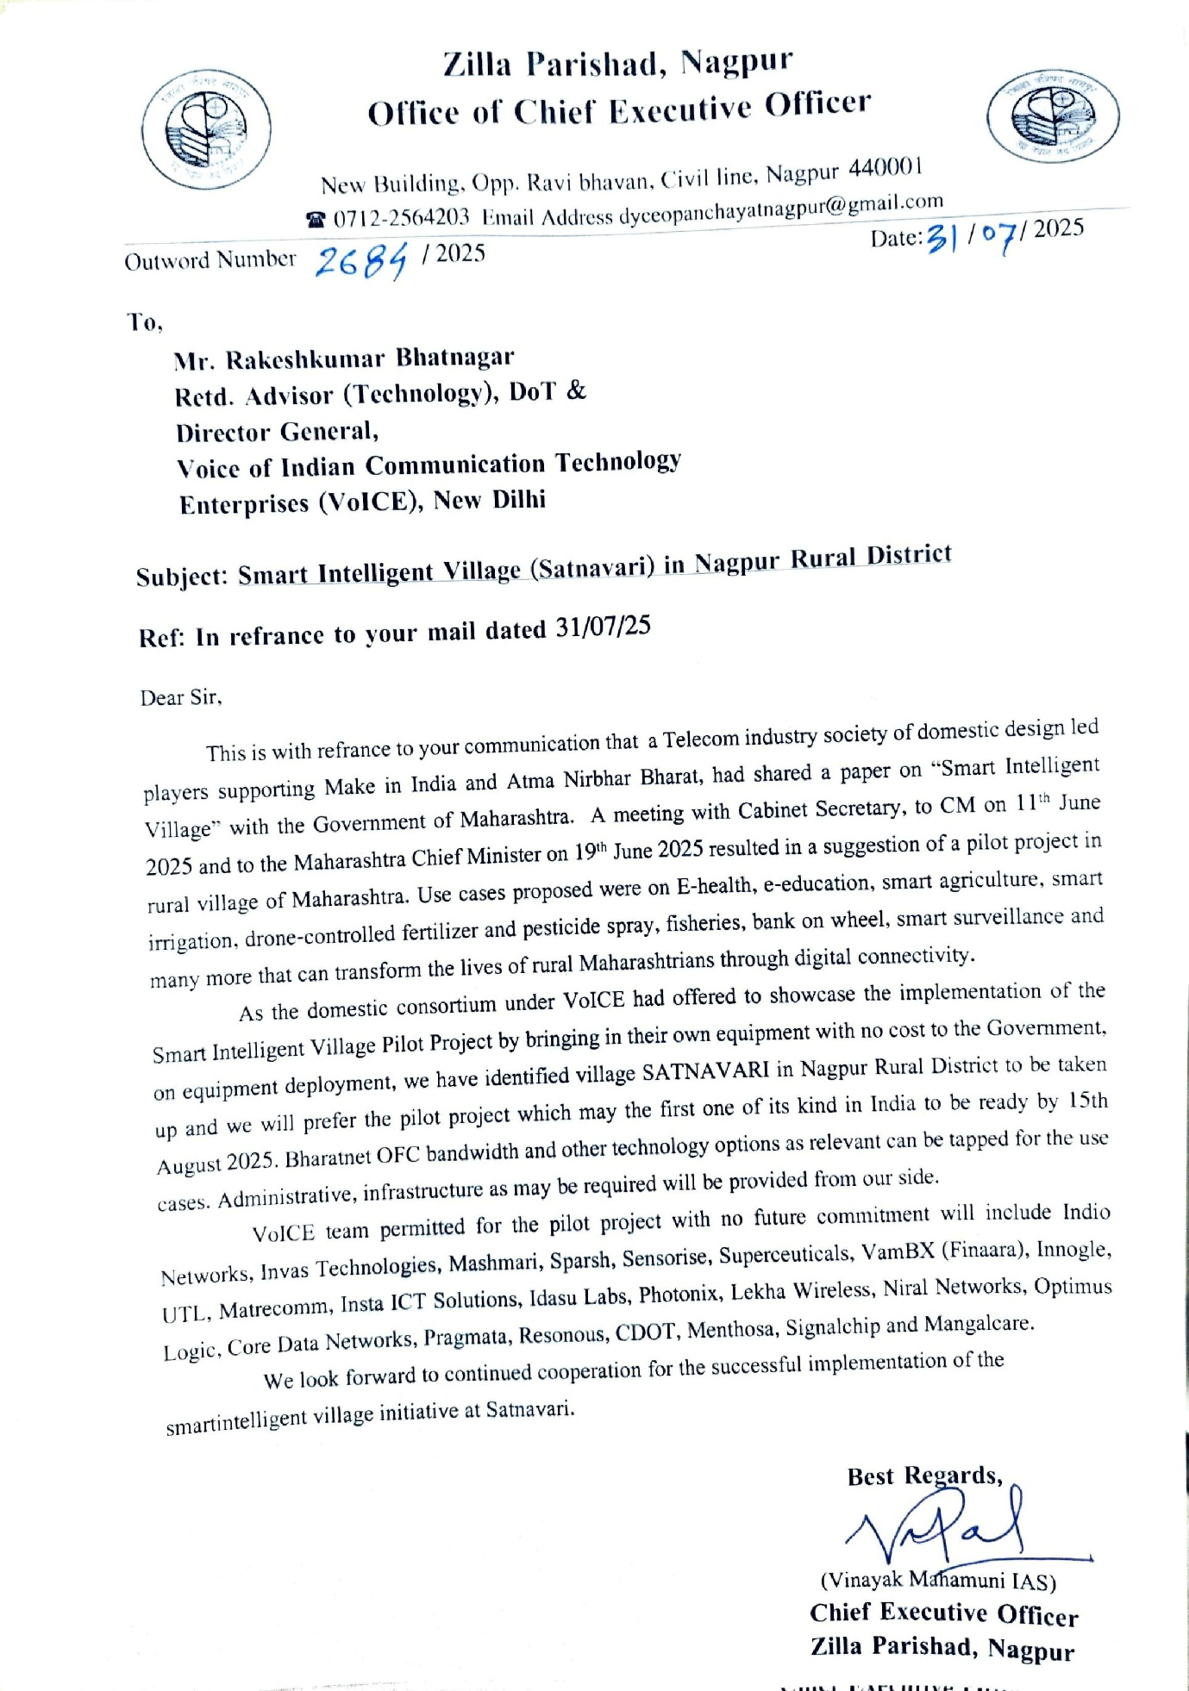

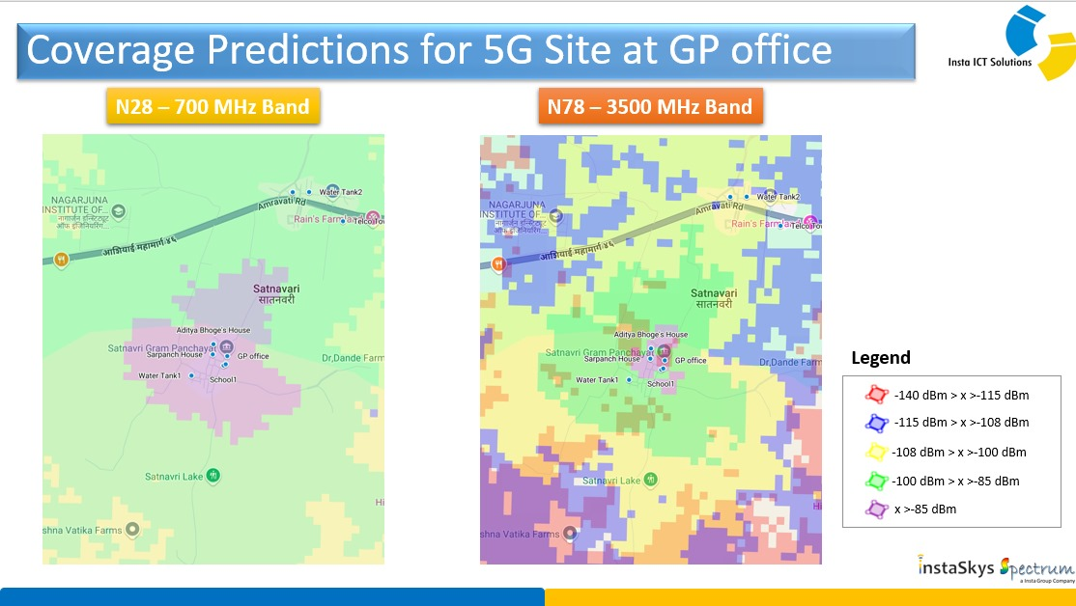

Coverage will be good through 5G. What is creditable is that it is the first Domestic Designed 5G deployment in the Rural parts of the country and existing deployments by JIO and Airtel are based on Imports and not based on Indian design. At a time, Atma Nirbharta in defence sector has paid dividends during Operation Sindoor, we can look forward to be a Global lead in 5G technology with 20 players ready to join 5 Global 5G suppliers.

Picture is of Foundation for 20 M Mobile Tower at Satnavari

From decision, design, fabrication and 20 M high tower will be ready on 5th August 2025 in a record 12 days record time and equipment will be mounted on 7th August 2025. Normally towers take 3 to 4 months’ time for installation and would an Indian and possibly global record.

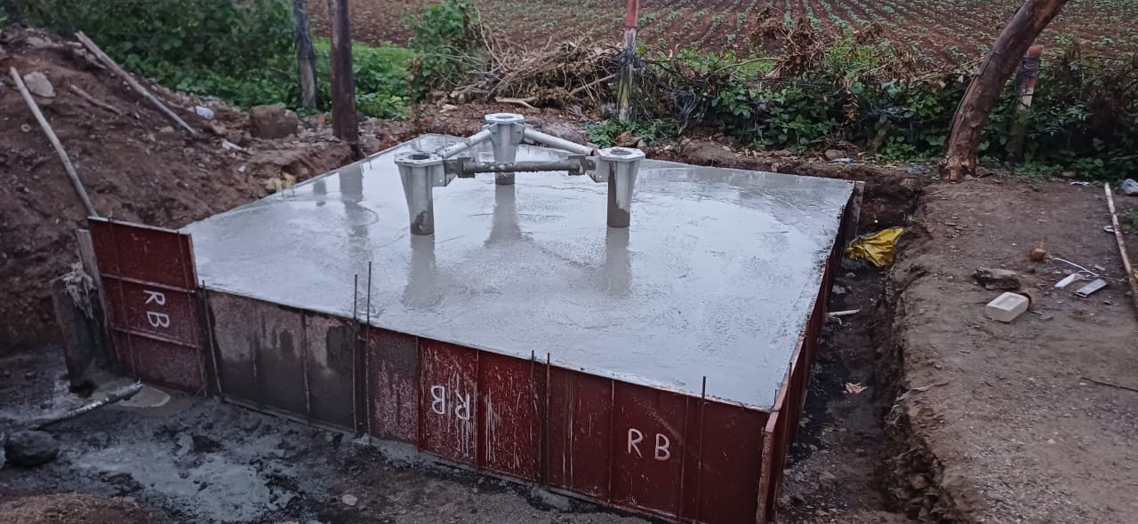

Sensors Deployed in Agri Fields

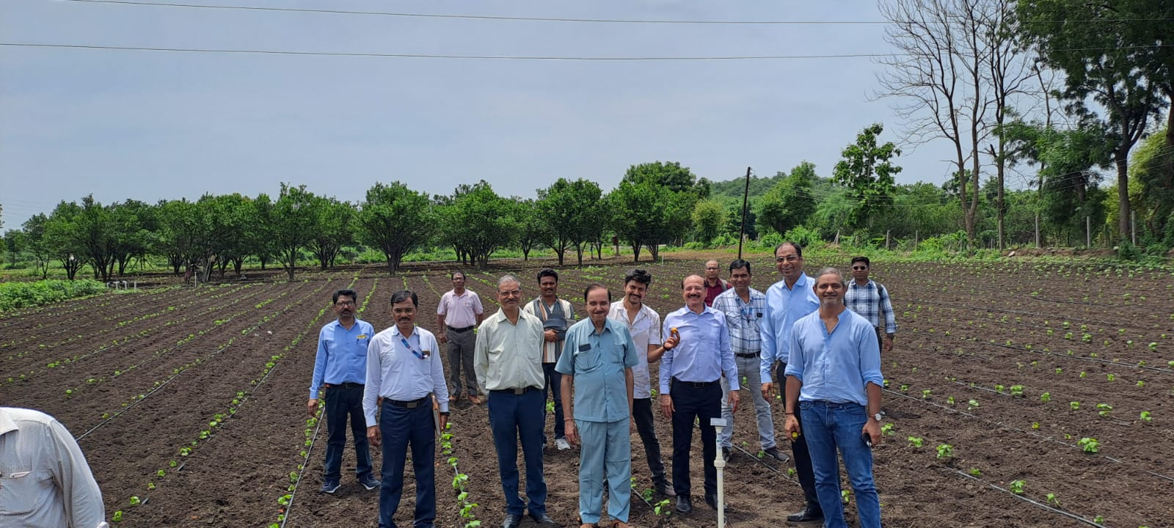

Getting Ready for Pond Solution & oxygen sensing : Fisheries

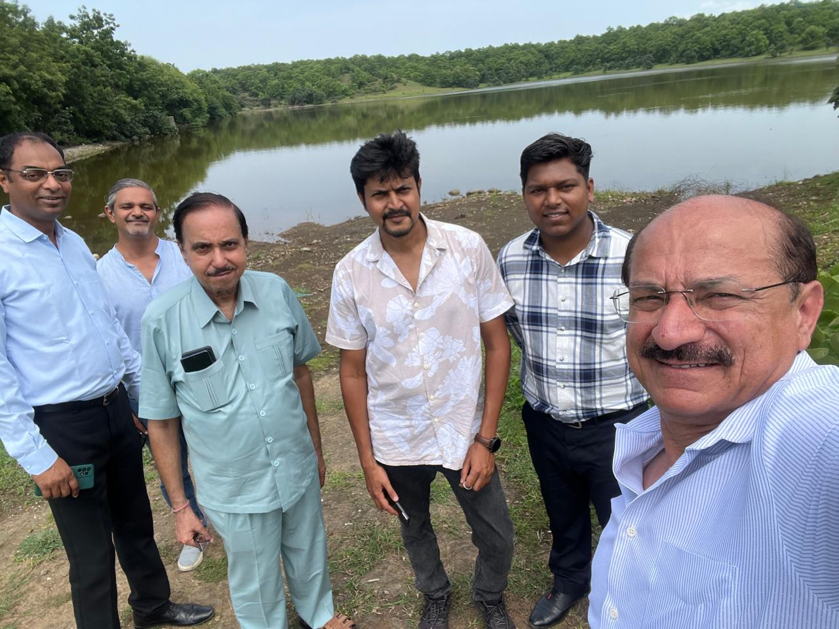

Connectivity for Agri Sensors

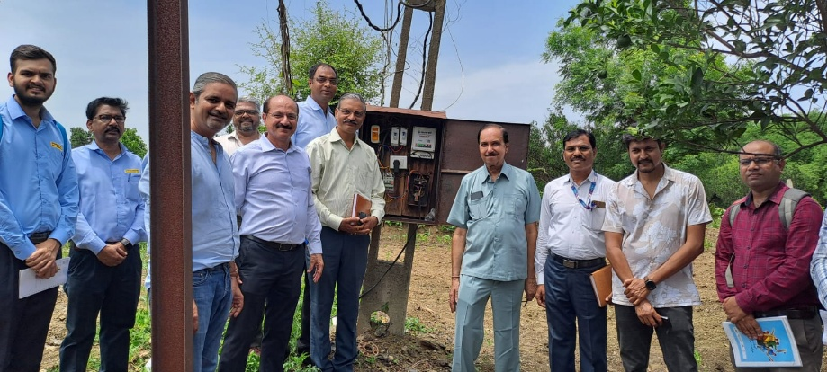

First WiFi Hot Spot at Panchayat Office

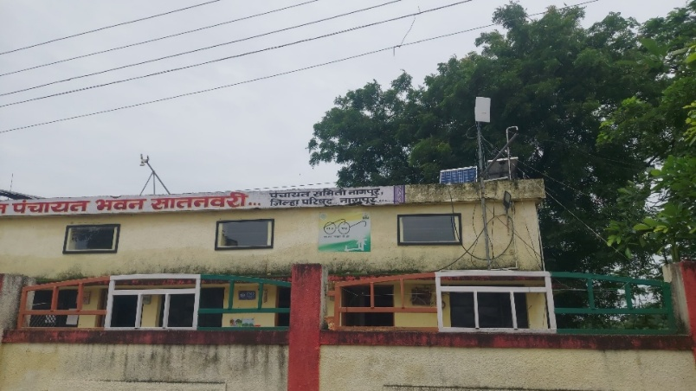

Another one at School Building

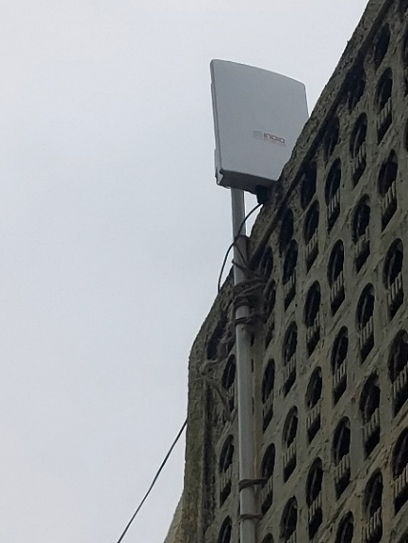

School Children playing with a small Drone. Bigger Drone will be used for Fertiliser and Pesticide spraying

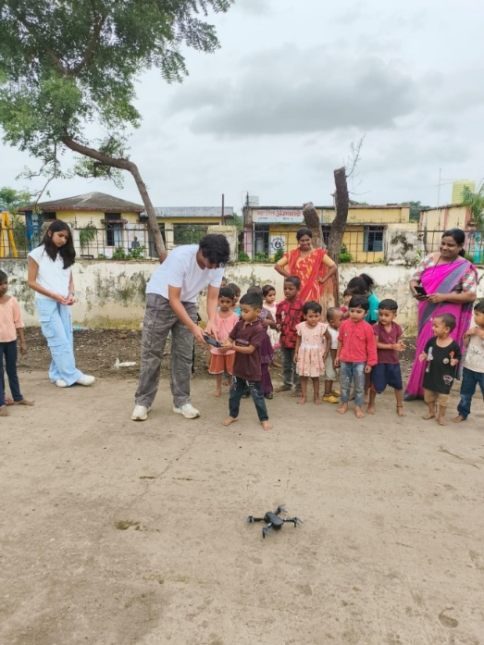

MEDIA REPORT ON THE PROJECT

<https://www.communicationstoday.co.in/indias-first-smart-intelligent-village-in-nagpur-pilot-by-august-15/>