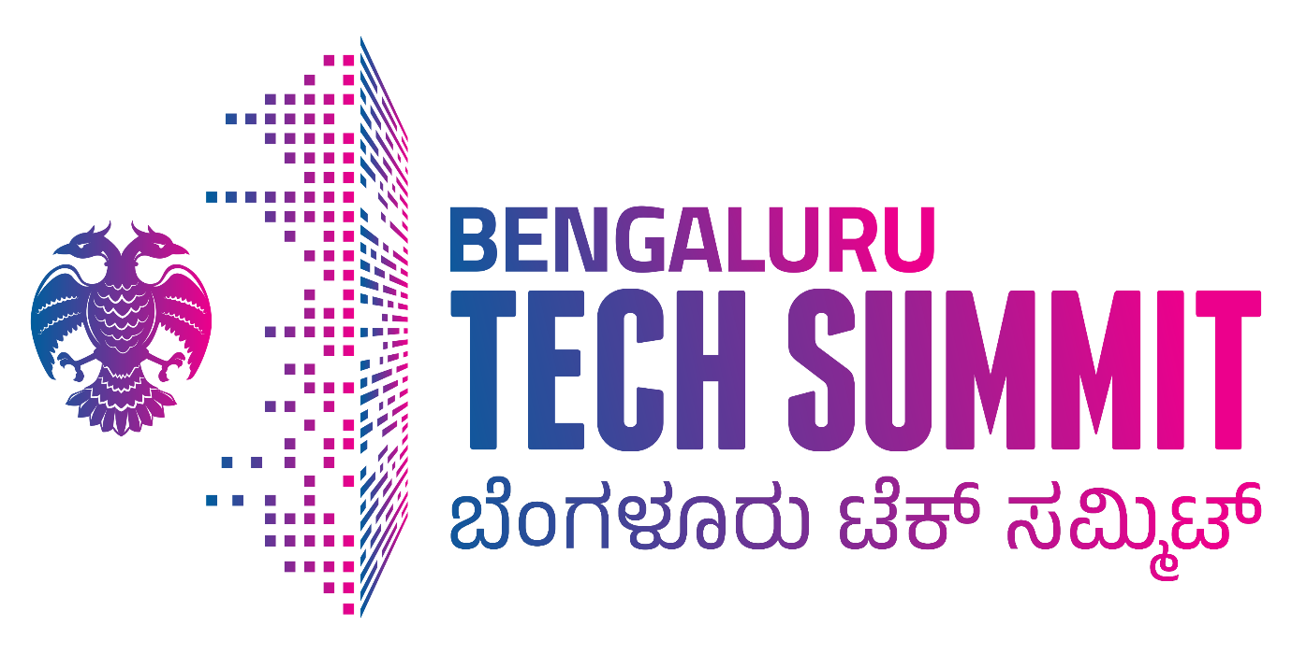

**VOICE CONSORTIUM**

**BTS2023**

**29-30 November & 1 December 2023**

**VoICE**

“Voice”, (Voice of Indian Comtech Enterprises), a society of indigenous telecom design companies recognised the need that customer does not buy a RAN, IMS, NMS or an IOT or M2M device. Customer wants an end to end solution to meet its functional requirements. Customer wants a Common management of the network, Common provisioning of the network, Common facility for taking report of the entire network, Common billing or voice logging mechanism. Customer needs a user experience that is simple and user friendly for all the subsystems and a dashboard from where the entire network can be managed from a central location

VoICE took the initiative to integrate various subsystems developed by Indian Startups and SMEs to provide a complete end to end system that will open opportunities in Utility companies, Railways, Mines, Oil and Gas as well as Defense applications. Collectively, this would be a large market that can resurrect domestic telecom design & manufacturing industry.

VoICE team has successfully hosted live demonstrations of “end to end” Private 5G /4G networks from indigenous technology SMEs and Startups during IMC2022 and IMC2023. Some companies demonstrated their IOT devices. Highlight of the demonstration was that entire platform on display had products from various Indian companies where hardware and software control resides with domestic players. Apart from the live demo of Private 5G network, on display were standalone products, applications and chipsets from various domestic companies.

Voice is confident that as a consortium, domestic companies can immediately deliver and meet requirements of setting up Enterprise / Private 4G networks immediately. Domestic industry with required support from Government schemes would be able to commercially deliver 5G private networks in 12-18 months.

Today Domestic technology companies are marching forward with all the ingredients such as design ownership, IPRs aptly supported by a robust equipment manufacturing and R&D ecosystem. Indigenous technology companies have made significant strides and have showcased “use cases” for applications in Mines, Railways, Defense as well as for utility companies like airports & metro projects. They claim they would deliver a perfect and better substitute to meet demands that are catered by imported Tetra radios used in these utility companies.

Consortium based solution that was showcased in IMC2023 included the following. Many of them are not present in Bengaluru Tech Summit but their solutions can be coordinated by VoICE.

|  |
| --- |
| 1. **DISASTER MANAGEMENT, HOMELAND SECURITY Consortium** |
| 1. **MOBILE NETWORKS DESIGNED FOR RURAL** |
| 1. **RAILWAYS 4G/ 5G NETWORK** |
| 1. **MOBILE INTEGRATED NETWORK** |
| 1. **THEATERISATION OF BATTLE FIELD** |
| 1. **TYPICAL 4G 5G CONVERGED NETWORK** |
| 1. **4G 5G MINING** |
| 1. **5G TESTING TOOLS, Ocean & Fishing, Financial Tech, Automobile, Logistics** |

**Contact: Rakesh Kumar Bhatnagar, Director General, VoICE**

**Mobile: 9350836103**

**Email: rkbhatnagar.dg.voice@gmail.com**

**BRIEF EXPLANATION OF EACH CONSORTIUM**

1. **DISASTER MANAGEMENT and MISSION CRITICAL (PTT)**

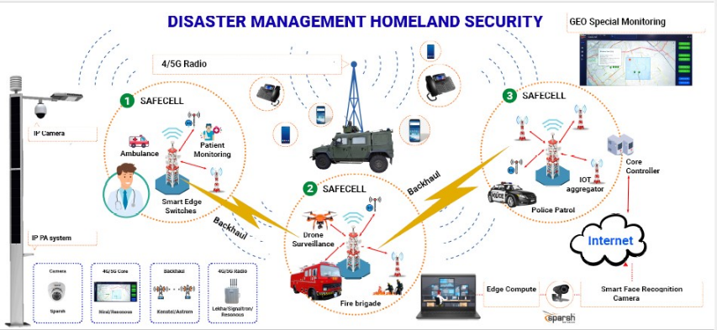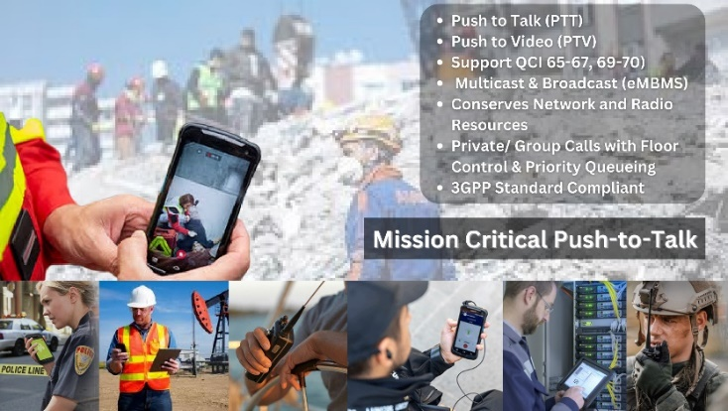

Disaster management plays very important role in keeping the community safe by planning, response, or recovery from emergency situations. Technology empowers the team to perform their functions effectively and seamlessly. Real time data from IOT sensors, real time videos of affected area and robust alert/announcement systems are some of the technological requirements that enable Disaster Management teams to ensure safety to the citizens. Disaster and homes security solutions cover distant geographic locations and Indian ecosystem can deliver extensive applications working on different technologies & protocols, necessary to have reliable robust and resilient network. VOICE consortium of Indian 4G / 5G stack can help build reliable core and robust field deployment solutions that can be the backbone for any disaster management requirement.

1. **4G 5G MOBILE NETWORKS DESIGNED for RURAL**

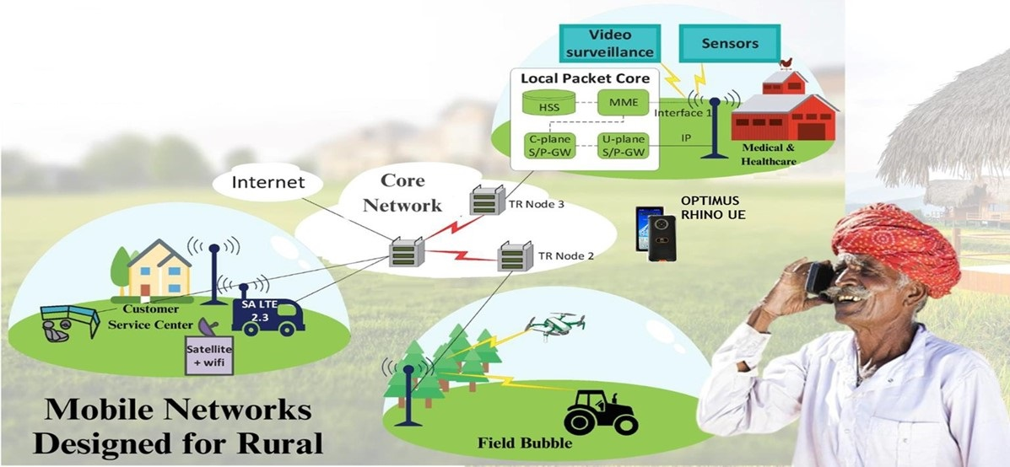

Rural and remote areas in developed or undeveloped countries around the world are facing the challenge for unavailability of unreliable high-quality Internet connectivity. Many IOT and smart applications have been developed around requirements of rural areas but challenge of availability of reliable, high-speed network with wide coverage to run these applications still exist. “Field Bubble” is the solution for requirement of communication in remote and in accessible areas that can be connected over various communication technologies like Satellite, Gigabit backhauls to connect the unconnected. Indian designs can create high speed and reliable network bubbles to run various applications in rural areas like Medical & Healthcare Facilities, Agriculture, Customer Service Centres. VOICE domestic 4G & 5G stack has developed and can provide end to end solution for the Rural Communication.

1. **RAILWAYS 4G 5G NETWORK**

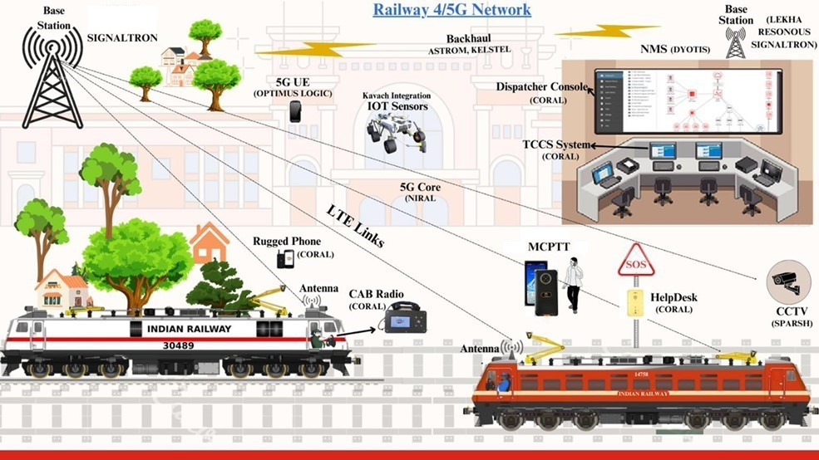

Indian railway is one of the largest Rail Network in the world and seamless communication is the backbone to run such a large Network. Different communication devices are used in Indian Railways that works on different Media, Network, Protocols and Applications such as FXS Landlines, IP Phones, Cab Radios, MCX devices, Dispatcher consoles and 4G/5G Phones. Domestic solutions for robust and seamless communication across disparate devices is of great importance and Indian solutions converging legacy devices with VOICE domestic 4G & 5G stack have demonstrated the power of innovative start-ups. Railway’s converged network solutions developed by Indian companies can be adopted globally that not only saves cost of deployment but also caters to resilience required in developing economies

1. **MOBILE INTEGRATED NETWORK**

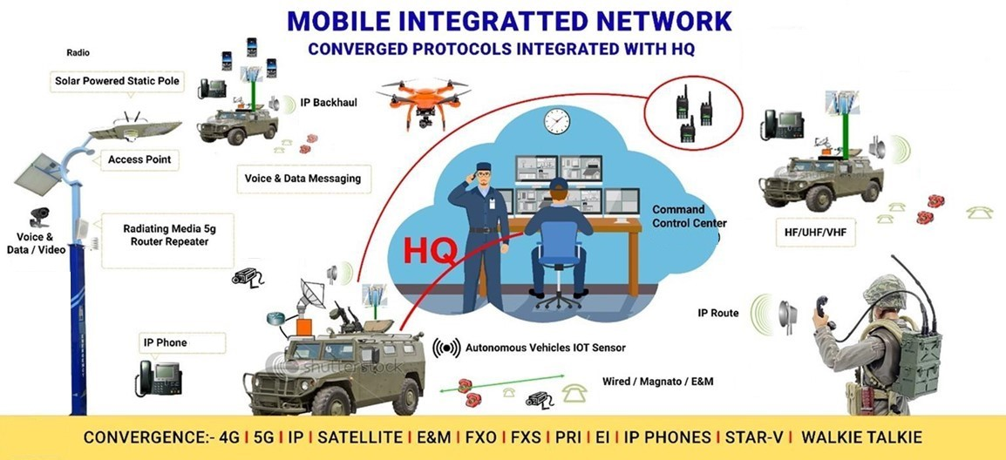

Converged Private Network Solution for Defense and Tactical Applications is inherently open, flexible, and future- proofed to take advantage of the rapidly developing 4G/5G technologies. Private wireless networks include the latest generation of 4G/5G that help to revolutionize mission-critical applications, connectivity can foster significant improvements, from safety to efficiency and productivity to better sustainability. Operations can be optimized by collecting and analyzing tracking data on the real-time location and performance of vehicles, equipment, and soldiers. A single infrastructure enables fast, reliable, and secure data, wide coverage, low latency, and assured quality of service (QoS). Converged Evolved Packet core (EPC) for 5G/4G networks can converge Voice, Data, IOT & M2M communication within the same enterprise network and opens a plethora of applications to address diverse requirements. The system allows seamless connectivity between mobiles (4g/5G), VF/UHF, IP Phones, Push to Talk (PTT) as well as legacy wired devices such as FXS Analog Phones through a common management and provisioning interface

1. **THEATERISATION OF BATTLE FIELD**

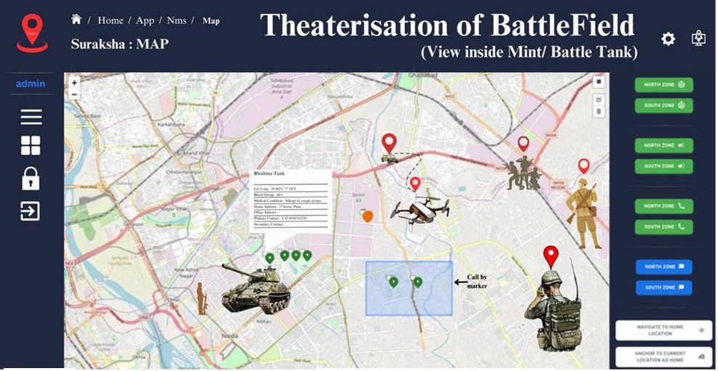

Indian Army is the pride of the nation that plays a very crucial role in fighting insurgents and protect homeland security. Domestic companies have designed solutions that can keep real-time track of our soldiers and our assets in the Battle Field. Solutions for Battle field theaterisation maintain central command and control in the most inhospitable terrains while facilitating communication on the move. Domestic solutions facilitate not only Geolocation map based communication but can also send alerts in a zone or to specific individuals as encrypted voice or text messages. The system allows real-time updates of enemy locations and activities. The system running on reliable captive 4G/5G network can be suitable application for Armed Forced. VOICE consortium of companies can provide end to end solution from 4g/5g connectivity, converged communication, Real time Geolocations and Alert Mechanism.

1. **TYPICAL 4G 5G SOLUTION**

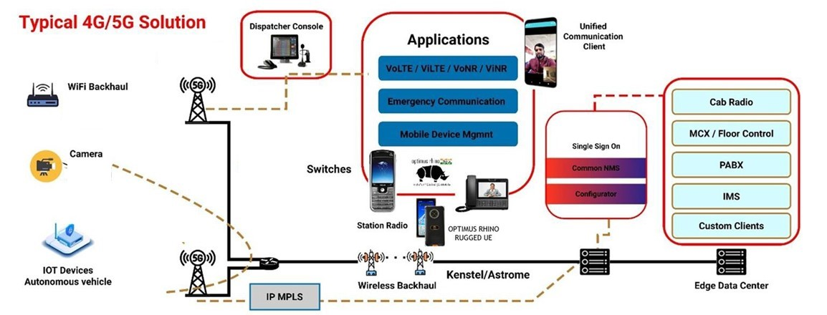

Massive digitalization wave taking place across industries with reliable and secure With high performance, low-latency private 4G/ 5G networks different Industries are taking leverage of better connectivity, converged communication and Industrial IoT (IIoT) to meet challenges and unprecedent analytics. 4G/5G Cellular networks are cost effective and scalable, while providing superior coverage. Cellular network provide increased performance and reliability, high-resolution video drones and automated guided vehicles (AGVs) can easily perform surveillance tasks with maximum precision and accuracy. VOICE with consortium of companies provides End to End 4G/5G Network Solutions developed in India for different Industries.

1. **4G 5G Automation of Mines**

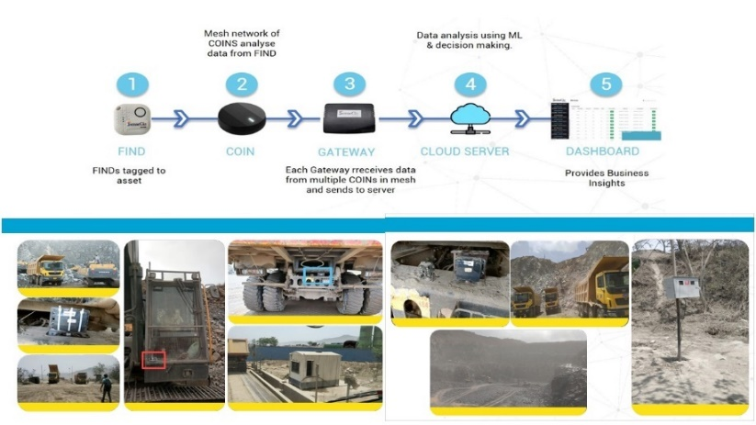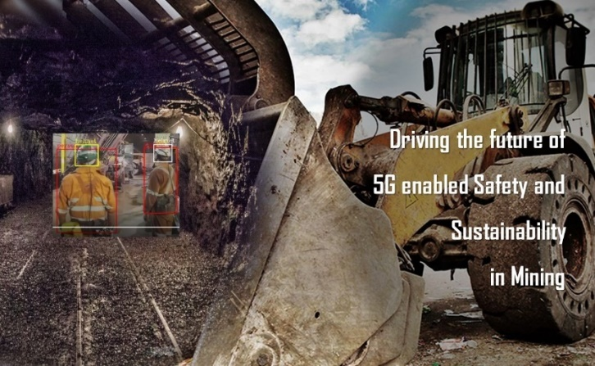

Automation is not easy in the mining industry, digging deeper into the earth for wired connectivity makes operations risky, increases chances of equipment failure and makes connectivity difficult. Private 5G’s increased throughput and low latency supports even the most advanced applications to enable smart mining. Various applications that can run on Private 4G/5G Network and help in automation of Mines by real time access to videos, data and voice.

Safety led comprehensive Anti-Collision Early Detection Solution between vehicles and humans addresses the safety requirements in civil, commercial and industrial construction industries, logistics and warehouses and overcomes the Industry challenges of worker safety, object detection and collision prevention, PPE detection and timely alerts. In Mining Industries, maintaining the record of trip count manually was difficult. Asset Tracking solution, we could help the mining industry by solving all these problems along with benefits like, Reduced manual entry of the trip counts & data fetching at any point of time. Loading & unloading time of the trucks could be easily identified.

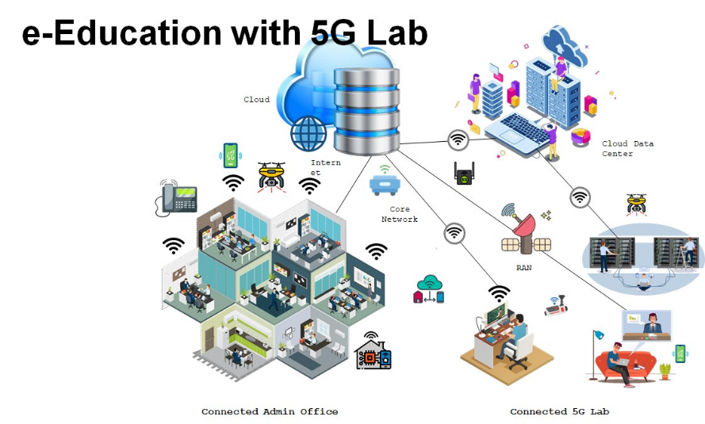**8. 5G TESTING TOOLS**